PRACTICAL - 2
AIM:

Implementation and Time analysis of linear and binary search algorithm.

BINARY SEARCH

ALGORITHM:

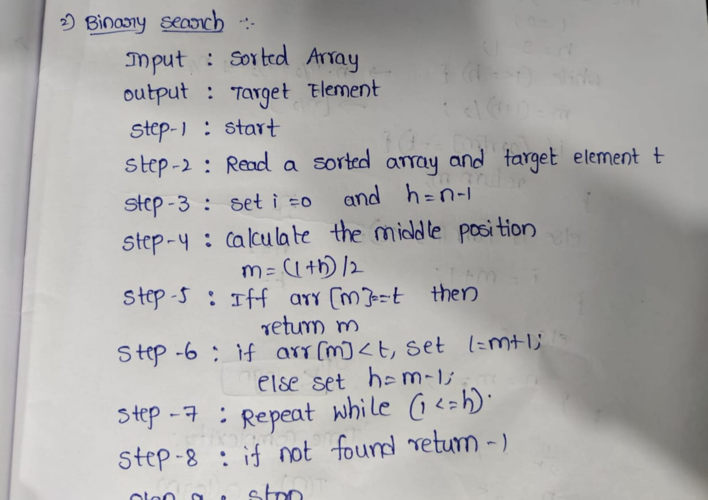

CODE:

#include <iostream>
using namespace std;

int main()
{
int n, arr[100], key;
int low, high, mid;

cout << "Enter size of array: ";
cin >> n;

cout << "Enter sorted array elements: ";

for(int i = 0; i < n; i++)
cin >> arr[i];

cout << "Enter element to search: ";
cin >> key;

low = 0;
high = n - 1;

while(low <= high)
{
mid = (low + high) / 2;

if(arr[mid] == key)
{
cout << "Element found at position " << mid + 1;
return 0;
}
else if(arr[mid] < key)
{
low = mid + 1;
}
else
{
high = mid - 1;
}
}

cout << "Element not found";

return 0;
}

OUTPUT:

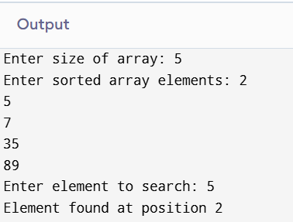

TIME COMPLEXITY:

best case:

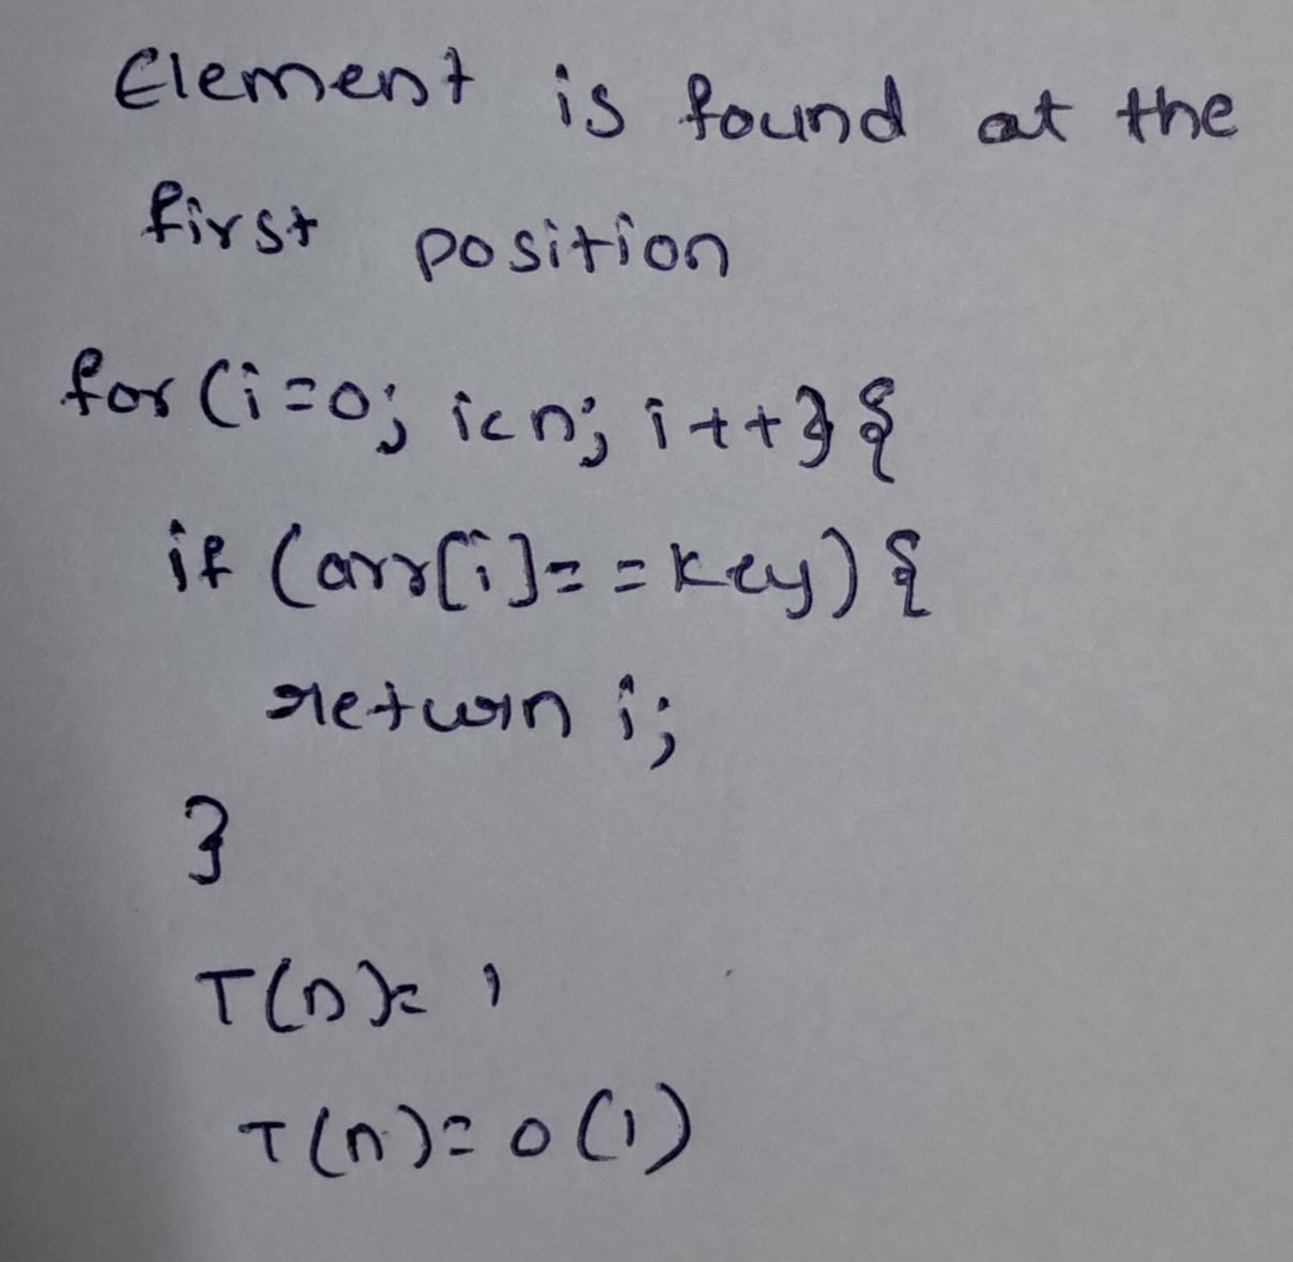

Average case:

Key is found after several divisions.

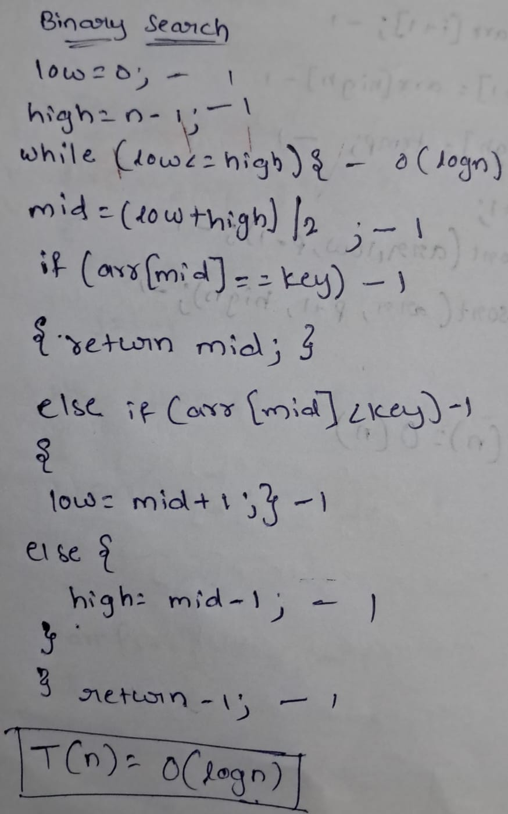

Worst case:
Key is found at the last division / not found.


LINEAR SEARCH

ALGORITHM:

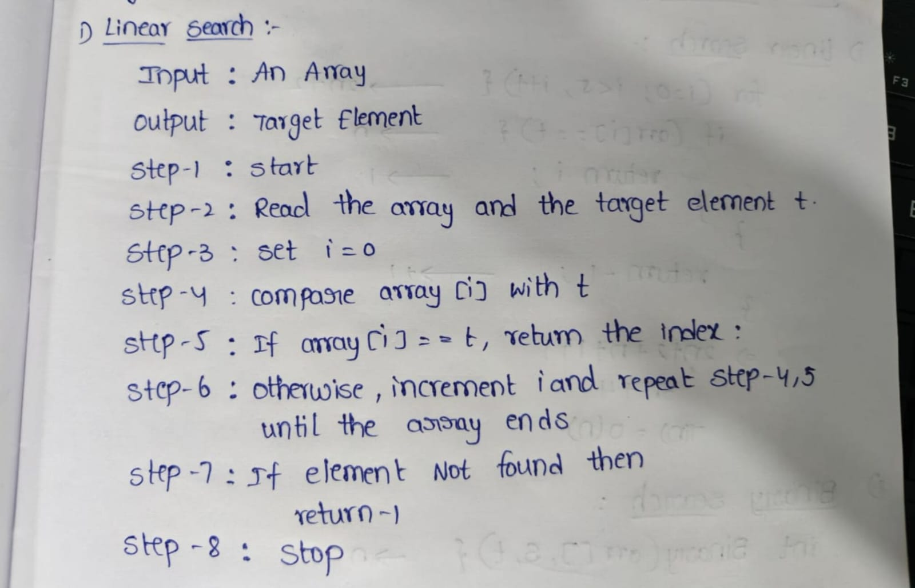

CODE:

#include <iostream>
using namespace std;

int main()
{
int n, arr[100], key;

cout << "Enter size of array: ";
cin >> n;

cout << "Enter array elements: ";
for(int i = 0; i < n; i++)
cin >> arr[i];

cout << "Enter element to search: ";
cin >> key;

for(int i = 0; i < n; i++)
{
if(arr[i] == key)
{
cout << "Element found at position " << i + 1;
return 0;
}
}

cout << "Element not found";

return 0;
}

OUTPUT:

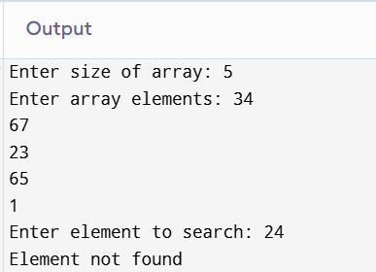

TIME COMPLEXITY:

Best case:



average case:

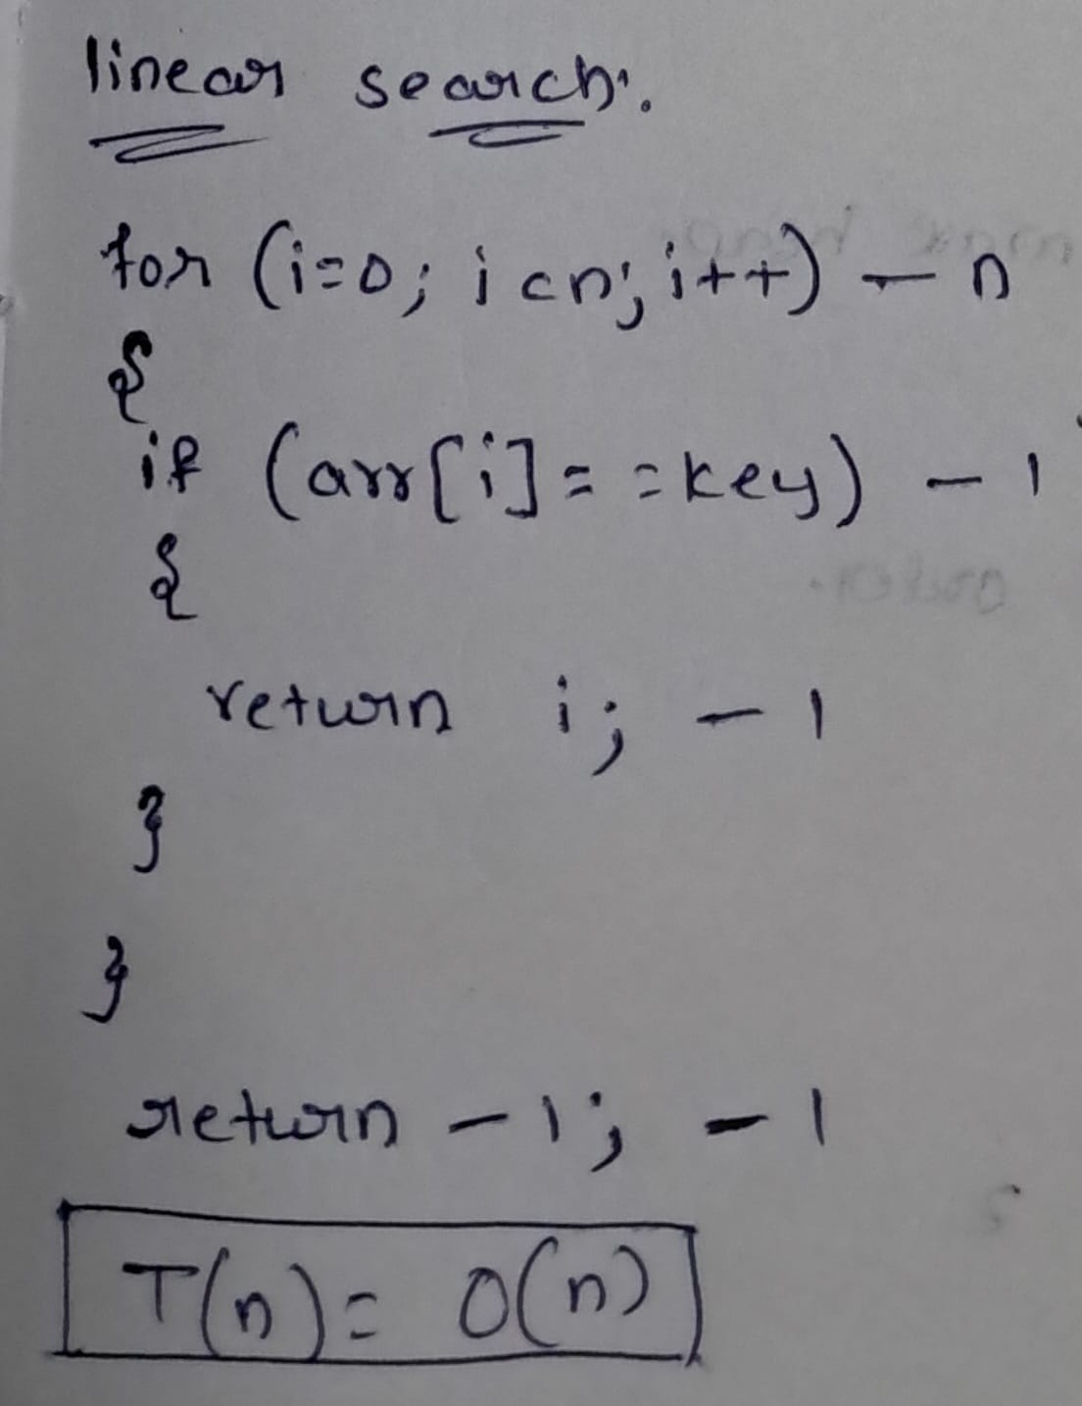
worst case:



CONCLUSION:

From this practical of linear search, Binary search the algorithm and programs have executed successfully. And Time complexity has categorised into three ways as Best, average and worst.

